

**December 13, 2019 – Advent 3 (B)**

**Third Week of Advent: Journeying with Community**

As we continue our Advent walk, we invite you to see the Way of Love as a journey that includes the community. The witness of Zechariah and Elizabeth who bring infant John to the Temple to be circumcised reminds us of the importance of our faith community to sustaining the Way of Love. Just as the community did for John’s family, communities provide a place for discernment, sometimes challenging us and other times affirming us. Communities celebrate and mark important moments along the journey.

**Sunday, December 13**

**WORSHIP**

Pray for each person as they receive communion. Imagine who you’d like to see at church next week. Invite that person to join you.

**Monday, December 14**

**GO**

Choose to take a different route to work, to school, or to play today. Whom or what did you encounter differently?

**Tuesday, December 15**

**LEARN**

Read Luke 1:64. When Zechariah could finally speak, he began by praising God. For what can you praise God? Share on social media or with a friend.

**Wednesday, December 16**

**PRAY**

Keep a lookout for anyone who might seem lonely, stressed, or sad. Offer this simple invitation: “May I pray for you?” Then offer prayers – silently or aloud – on the person’s behalf as you move through your day.

**Thursday, December 17**

**BLESS**

Identify a blessing you have that you could give away. Share this blessing with your church, a local ministry, or your community.

**Friday, December 18**

**TURN**

Turn away from the busyness of the week and turn toward someone who gives you life or to whom you give life. Give thanks.

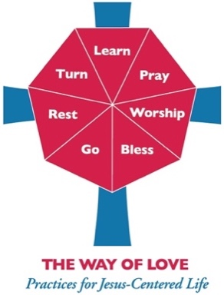**Saturday, December 19**

**REST**

In Genesis 1-2, God calls the creation “good” and rests. What can you proclaim to be “good” instead of “not enough” as a witness to God’s love for the world today?

For more Advent resources related to the Way of Love, visit episcopalchurch.org/wayoflove. There, you’ll find links to the full Advent curriculum *Journeying the Way of Love*, as well as *Living the Way of Love in Community,* a nine-session curriculum for use anytime.