

January 14, 2024 – Epiphany 2 (B)
Young Adult Service Corps

Offering a new extended age limit, the Young Adult Service Corps (YASC) invites Episcopalians ages 21 to 35 to consider a year of international mission engagement as their “next faithful step.”

Applications for 2024-2025 placements are being accepted. The deadline to apply online is Feb. 16.
For more than two decades, YASC participants have served in areas of administration/communication, agriculture, community development, education, health care, parish ministry/chaplaincy, social services, youth work, and more, while participating in the daily life and ministry of churches, cathedrals, and dioceses around the Anglican Communion.

Alumni repeatedly share about the deep, life-changing impact of their year of growth and service.
“YASCers cross boundaries, engage with diverse viewpoints, listen deeply, and have the chance to live like Jesus in new ways and places,” said Elizabeth Boe, Episcopal Church mission personnel officer, and former YASC volunteer in Tanzania from 2008-2010. “As Christians, we are a people of story. Some of the best parts

January 14, 2024 – Epiphany 2 (B)
Young Adult Service Corps

Offering a new extended age limit, the Young Adult Service Corps (YASC) invites Episcopalians ages 21 to 35 to consider a year of international mission engagement as their “next faithful step.”

Applications for 2024-2025 placements are being accepted. The deadline to apply online is Feb. 16.
For more than two decades, YASC participants have served in areas of administration/communication, agriculture, community development, education, health care, parish ministry/chaplaincy, social services, youth work, and more, while participating in the daily life and ministry of churches, cathedrals, and dioceses around the Anglican Communion.

Alumni repeatedly share about the deep, life-changing impact of their year of growth and service.
“YASCers cross boundaries, engage with diverse viewpoints, listen deeply, and have the chance to live like Jesus in new ways and places,” said Elizabeth Boe, Episcopal Church mission personnel officer, and former YASC volunteer in Tanzania from 2008-2010. “As Christians, we are a people of story. Some of the best parts
of our faith journeys are the surprises and connections we discover along the way. For those in their 20s and early 30s exploring who they are, where they fit in the church and the world, and what difference they can make, YASC might well be the next faithful step in the story of their lives.”

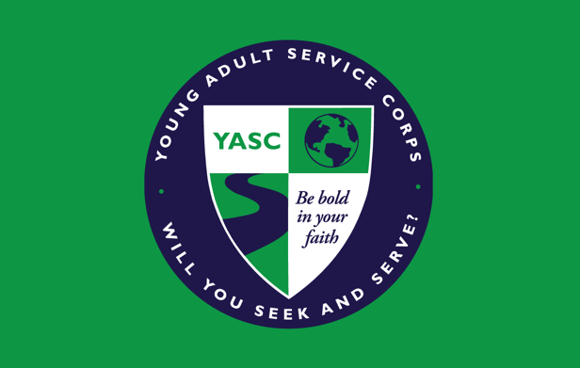
Applicants invited to continue the process have the chance to attend a discernment retreat as a next step toward determining if they want to participate in YASC. The retreat is an opportunity to continue conversations and discernment with others asking similar questions. Those interested in particular fields of service can potentially be matched to those areas.

Since the start of the corps, volunteers have served in more than 40 countries. Potential placement locations for 2024-2025 include, but are not limited to, the Convocation of Episcopal Churches in Europe, Costa Rica, the Dominican Republic, Ecuador, El Salvador, England, Ghana, Jerusalem, Kenya, Mexico, Oman, Panama, the Philippines, South Africa, Sri Lanka, and Tanzania.

Learn more about YASC and view videos from participants: iam.ec/yasc. Questions? Contact Elizabeth Boe at eboe@episcopalchurch.org.

of our faith journeys are the surprises and connections we discover along the way. For those in their 20s and early 30s exploring who they are, where they fit in the church and the world, and what difference they can make, YASC might well be the next faithful step in the story of their lives.”

Applicants invited to continue the process have the chance to attend a discernment retreat as a next step toward determining if they want to participate in YASC. The retreat is an opportunity to continue conversations and discernment with others asking similar questions. Those interested in particular fields of service can potentially be matched to those areas.

Since the start of the corps, volunteers have served in more than 40 countries. Potential placement locations for 2024-2025 include, but are not limited to, the Convocation of Episcopal Churches in Europe, Costa Rica, the Dominican Republic, Ecuador, El Salvador, England, Ghana, Jerusalem, Kenya, Mexico, Oman, Panama, the Philippines, South Africa, Sri Lanka, and Tanzania.

Learn more about YASC and view videos from participants: iam.ec/yasc. Questions? Contact Elizabeth Boe at eboe@episcopalchurch.org.

