

February 4, 2024 – Epiphany 5 (B)

Becoming Beloved Community Grants

Applications are open for another round of Becoming Beloved Community grants to help support The Episcopal Church’s work of racial justice, healing, reconciliation, and creation care. The deadline to apply is March 1.

Find criteria and the application online at iam.ec/bbcg.

Funds for these grants were first allocated in 2018 by the 79th General Convention; in 2022, the 80th General Convention approved further funding “for the continued implementation of additional work of organizing our efforts to respond to social and racial injustice and grow a Beloved Community of healers, justice makers and reconcilers.”
Applicants are encouraged to first reflect on The Episcopal Church’s resource, “Becoming Beloved Community Where You Are,” which describes specific ways to engage in this work. Projects that advance any of the quadrants of the Becoming Beloved Community labyrinth are welcomed.

February 4, 2024 – Epiphany 5 (B)

Becoming Beloved Community Grants

Applications are open for another round of Becoming Beloved Community grants to help support The Episcopal Church’s work of racial justice, healing, reconciliation, and creation care. The deadline to apply is March 1.

Find criteria and the application online at iam.ec/bbcg.

Funds for these grants were first allocated in 2018 by the 79th General Convention; in 2022, the 80th General Convention approved further funding “for the continued implementation of additional work of organizing our efforts to respond to social and racial injustice and grow a Beloved Community of healers, justice makers and reconcilers.”
Applicants are encouraged to first reflect on The Episcopal Church’s resource, “Becoming Beloved Community Where You Are,” which describes specific ways to engage in this work. Projects that advance any of the quadrants of the Becoming Beloved Community labyrinth are welcomed.
Grants include seed grants up to $7,500 and impact grants up to $15,000. Seed grants are geared toward groups launching new projects or growing existing projects. Impact grants are aimed primarily at increasing the capacity, impact, and reach of communities and institutions already working to advance justice, healing, reconciliation, and creation care.

“These grants are more than just financial support; they are a testament to our unwavering commitment to fostering inclusive, loving communities that embody the spirit of togetherness and understanding,” said the Rev. Edwin Johnson, chair of the Becoming Beloved Community Advisory Group. “Each grant represents a unique opportunity to bring transformative projects to life–projects that build bridges, heal divides, and spread love in tangible ways.”

Since 2019, approximately 80 projects have been funded by Becoming Beloved Community grants for a total of $808,850.

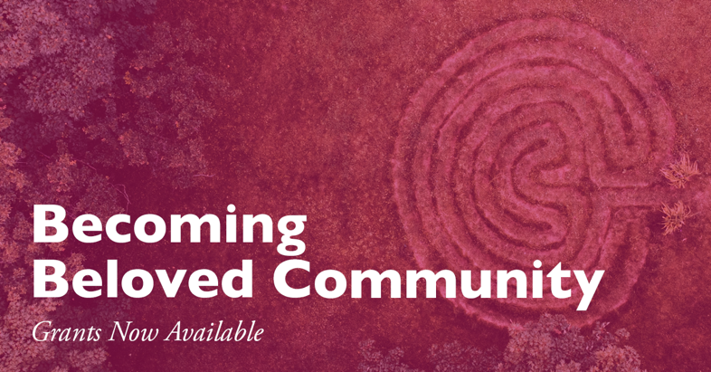

Grants include seed grants up to $7,500 and impact grants up to $15,000. Seed grants are geared toward groups launching new projects or growing existing projects. Impact grants are aimed primarily at increasing the capacity, impact, and reach of communities and institutions already working to advance justice, healing, reconciliation, and creation care.

“These grants are more than just financial support; they are a testament to our unwavering commitment to fostering inclusive, loving communities that embody the spirit of togetherness and understanding,” said the Rev. Edwin Johnson, chair of the Becoming Beloved Community Advisory Group. “Each grant represents a unique opportunity to bring transformative projects to life–projects that build bridges, heal divides, and spread love in tangible ways.”

Since 2019, approximately 80 projects have been funded by Becoming Beloved Community grants for a total of $808,850.

