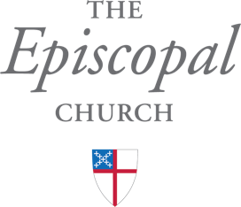

RECORD of CONFIRMATION
For permanent filing in the Office for the Armed Forces and Federal Ministries of The Episcopal Church.
If you wish to have a copy of this record transferred to a parish, please contact the Office for Armed Forces and Federal Ministries.

__________________________________________________________________________________________
full name of person being confirmed

was confirmed on the ______ day of ________________ in the year ___________
day month year

at ______________________________, ______________, _______________.
location city state

Sex: __________ Date of Birth: ____________ City and State: ________________________

Date of Baptism: ____________________________ Place of Baptism: ___________________________

Presented by: ______________________________________________________

_________________________________________________________________

Officiating Bishop’s Name: __________________________________________

Officiating Bishop’s Signature: ________________________________________

Armed Forces and Federal Ministries - The Rt. Rev. Ann Ritonia
3101 Wisconsin Avenue NW, Washington, DC 20016

